CAS PY 106

Pre-session Note 23

1. The Doppler Effect
2. The Doppler effect is the shift in frequency of a wave that occurs when the wave source, or the detector of the wave, is moving.
3. Applications range from medical tests using ultrasound to police speed traps using radar to astronomy
4. Both source and observer are at rest
5. f = v / lambda where v is the speed of sound through the medium
6. 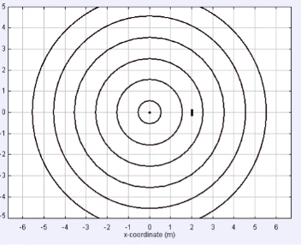
7. Doppler effect: a moving observer
8. When you move toward the source, you encounter more waves per unit time than you did before
9. Effectively, the motion of the observer changes the wave speed
10. 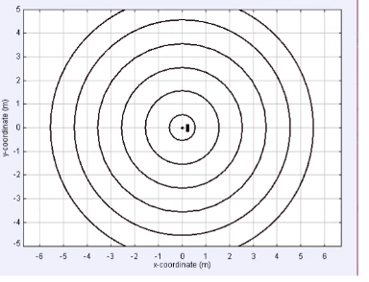
11. From the observer’s perspective
12. For you, the entire pattern is traveling toward you, unchanged
13. 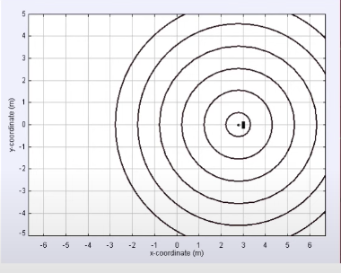
14. A moving observer
15. Relative to you, the waves travel at a higher speed:
16. v’ = v + vo
17. If you move away from the source, the relative speed between you and the waves would be lower. In either case, this shifts the frequency of the waves you hear, to:
18. 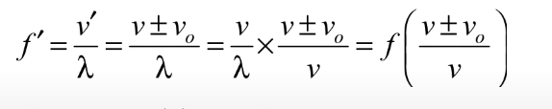
19. Use the plus sign when the observer moves toward the source, and the negative sign when the observer moves away
20. If you move away from the source, the observed frequency is less than the source frequency
21. 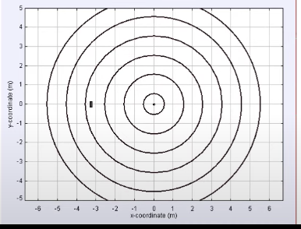
22. Doppler effect: a moving source
23. If the source moves toward the medium, the situation looks a little different
24. Produces asymmetric pattern
25. 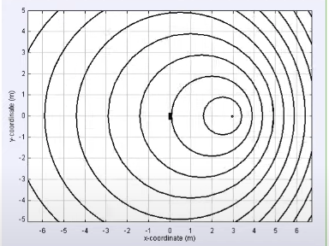
26. A moving source
27. The motion of the source effectively changes the wavelength to:
28. 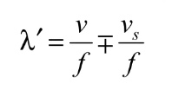
29. Use the negative sign when the observer moves toward the source, and the positive sign when the observer moves away
30. The detected frequency is:
31. 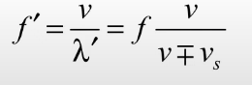
32. The Doppler effect in general
33. In some situations, both the source and the observer move.
34. The general Doppler equation combines the previous results
35. 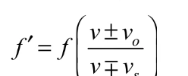
36. For both sets of signs, use the top sign when the motion is toward the other thing and the bottom sign when the motion is away